The Hartsdale Fire Department is proud to announce our annual Operation Candy Cane, which will take place rain or shine on Sunday, December 20th, 2020 from 9am – 1pm. Off-Duty Hartsdale Professional Firefighters will spread Holiday Cheer by escorting Santa Claus around the community in a Fire Apparatus Sleigh handing out Candy Canes to all attending children & adults. Printed below is a full list of Stops & Times. To make sure everyone is at the correct location awaiting Santa’s arrival, the Location Marker Signs shown below will be posted at every stop. Due to the busyness of Santa’s schedule, please allow for some flexibility with our estimated arrival times. Due to safety concerns, we ask that all children are accompanied by an adult, stay clear of the apparatus, and arrive at the designated locations approximately 10 minutes prior to the posted times.
In order for this event to take place during this pandemic, we will be adhering to the following Covid19 Safety Protocols and Social Distancing Recommendations and we ask that all participating members of the community do the same:

- All HFD members involved will wear masks and gloves including Santa.
- All HFD members involved will self-monitor and have their temperatures checked upon reporting for the detail.
- Any HFD member who does not feel well or has an elevated temperature or fever will not participate.
- Sanitizer will be available for all members and participants to use.
- All individually wrapped Candy Canes will be handed out by limited personnel.
- All interactions and photography will be socially distant.
For more information regarding Operation Candy Cane, updates, or for more interesting information about the Hartsdale Fire Department’s services, news, activities, or fire safety and prevention please check out our website at hartsdalefire.org. We want to wish everyone a safe and healthy Holiday Season…!
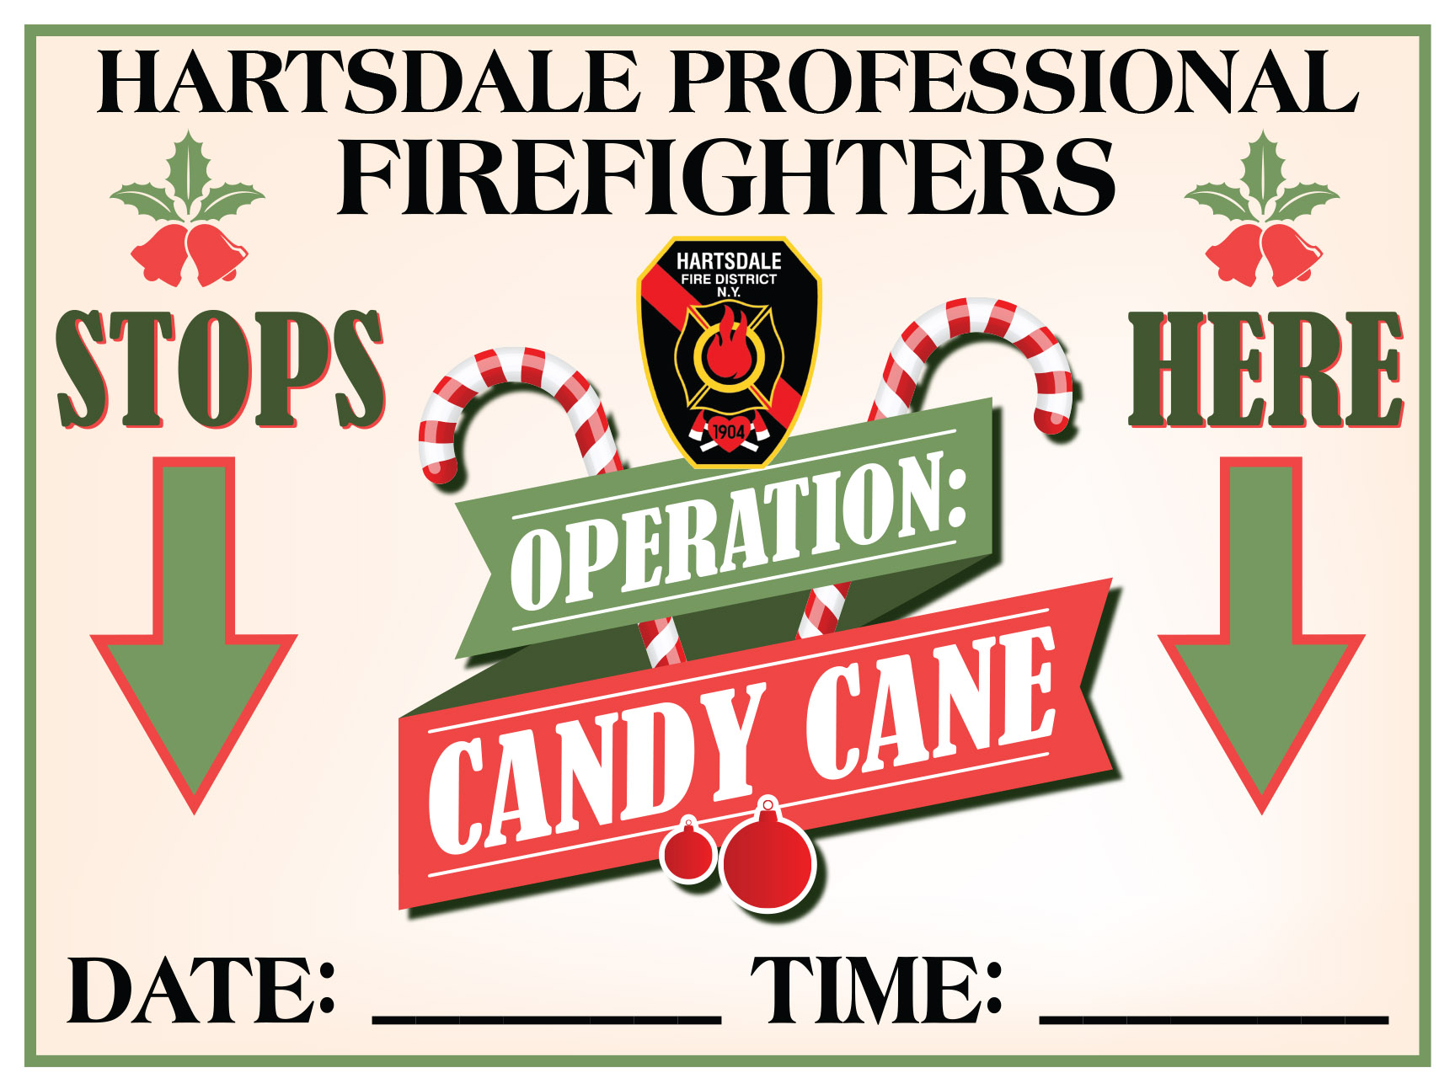

9:00 HARTSDALE TRAIN STATION
9:15 ROCKLEDGE CIRCLE / ROCKLEDGE ROAD
9:22 LAKEVIEW AVE / MAPLE STREET
9:29 CORNELL DR / PRINCETON DR
9:36 15 FIELDSTONE DR
9:43 BRIAR CLOSE / COLONY DR
9:50 BLDG 1 @ 125 N. WASHINGTON AVE
9:57 71-79 N. WASHINGTON AVE
10:04 PINEWOOD / WILDWOOD RD
10:11 HOMEWOOD CT
10:32 WOODS END RD / WOODS END LN
10:39 SHAW PL / SPENCER CT
10:46 STEVENSON AVE / POE ST
10:53 TENNYSON ST / HOLMES AVE
11:00 HOLMES AVE / BURNS ST
11:07 BARBARA LN / JEAN LN
11:14 EDGEWOOD RD / CROSS WAY
11:21 SHERBROOKE / BURKEWOOD RD
11:28 SOUTHERN RD / HOWARD PL
11:35 61-69 SECOR RD
12:00 TRADER JOE’S (Outside Only)
12:15 MARION WOODS (Outside Drop off Only)
12:30 HARTSDALE TRAIN STATION/VILLAGE

